
[NAME OF GROUP]
EDI ACTION PLAN 2024-2025
Published: XXXXXXX
Introduction
Bristol SU is loud and proud about equality, diversity, and inclusion.
We are proud of our values and care about creating diverse and supportive communities that are inclusive of age, disability, gender, identity, race, religion, sexual orientation, and experience. We are a Union for all students and expect our student groups to reflect this too.

Your Equality Statement
An equality statement is simply a written statement from your group about how you will avoid discriminating against people, and how you will create a safe and inclusive atmosphere for your members.
Have a Discussion
- Have a discussion in your committee about equality and diversity and what it means to your group to treat everyone with equal respect.
  - What kinds of discrimination and harassment are you aware of?
  - Do any of your group have any personal experiences of exclusion?
  - Which groups of people are more likely to face discrimination and harassment? How could this affect your group?
Write your Statement
- This could be quite short and simple. For example: “Bristol Flops is committed to treating all people equally and with respect irrespective of their age, disability, gender reassignment, marriage or civil partnership, pregnancy or maternity, race, religion or belief, sex, or sexual orientation”.
- Make sure the discussions you’ve had as a group help shape your statement.
Use your Statement
- Your statement should be shared with all members and adopted as part of your group. Make sure that you discuss and review it regularly.

Your EDI Action Plan
An EDI action plan is an active document used to help break down barriers to participation and find mitigating actions to help make your group more inclusive, equal and diverse.
Your plan should be informed by your Equality Statement and actively updated and referred to during committee meetings. We advise you to choose three barriers to participation to focus on.
Here are some examples to get you started:
 | Barriers to Participation | Potential Actions
Perceptions | Fear of discrimination | Make members aware of the SU's Code of Conduct and expectations around behaviour; introduce an anti-bullying policy with clear consequences for those that don't follow it; make your anti-discrimination stance clear in promotional materials; hold an international night that celebrates the countries members come from; encourage members to actively speak out against sexism, racism, homophobia etc.
Perceptions | Fear of peer pressure | Establish a clear opt-in approach e.g. no expectation to attend a social after a session; mention relaxed activities and socials when publicising your group; make it clear to members that they should not pressure others into doing anything they don't want to
Perceptions | Fear of sexual harassment | Introduce a zero-tolerance policy on sexual harassment and inform members about it; ask venues for their policy on sexual harassment and only run socials in places where this is robust; make members aware of the SU's Code of Conduct and expectations around behaviour
Perceptions | Fear of reduced participation due to cost | Provide activities (including socials) with no cost; provide a list of all potential costs throughout the year; mention the SU's Activity Hardship Fund at the start of the year and when promoting any events that aren't free (or other costs such as personal equipment or kit); be transparent if your group's activities are not accessible for all budgets so that students can make an informed decision before joining your group/getting more involved
Perceptions | Fear of stereotypes | Gather feedback to find out how your group is perceived and how you could make effective changes; make proactive social media posts that welcome under-represented groups and particularly encourage them to give your group a go; film events and socials to show videos of a diverse range of people taking part in your activities
Timing | Lack of events outside of term-time | Provide sessions outside of term-time, during the Christmas, Easter and summer breaks; organise trips outside of term-time; help students who will be in Bristol outside of term-time to connect with others in a similar position
Timing | Unable to make certain times | Provide sessions at various days/times; make it possible for students to drop in/out of sessions; share the slides from (careers/skills) events with those that were unable to attend
Timing | Unable to make events at short notice | Create a timetable/programme of events (including socials) for each term; provide full details of events at least two weeks in advance; host events online or share the slides from (careers/skills) events with those that were unable to attend
Timing | Difficulty managing changes to times/locations | Release tickets for events at the same time each week; try to use the same location for regular activities or provide clear information about new locations
Timing | Unable to make large time commitments and/or regular commitments | Provide open sessions throughout the year that don't require commitment; provide opportunities for short-term commitment (projects, day events, weekends); make sure students are aware of the commitment they will need to make for different activities well in advance; make it possible for students to drop in/out of sessions; make sure that events avoid overrunning and keep to the advertised timing
Events | Cost of participation | Reduce costs e.g. membership cost; advertise the SU's Activity Hardship Fund; run more free/cheap activities (including socials); make sure members and prospective members are aware of upcoming costs well in advance; create different membership options e.g. pay-per-session; provide/have equipment that can be borrowed by those that need to; establish a clear expenses policy; be transparent if your offer isn't accessible for all budgets so that students can make an informed decision
Events | Lack of alcohol-free events and socials | Provide alcohol-free events/socials e.g. bowling, film night, mini golf, board games, scavenger hunt, picnic
Events | Lack of inclusive facilities (gender neutral toilets/changing rooms, childcare, prayer facilities etc.) | Choose venues with inclusive facilities; ask venues to provide inclusive facilities; book rooms with a gender-neutral toilet and/or prayer room nearby; provide child-friendly events/socials; have a sign language interpreter at events; take prayer times into account when planning activities
Events | Lack of or too many mixed gender activities and issues around team participation | Provide both mixed gender and single gender sessions and teams; campaign for mixed gender competitive teams nationally
Events | Information about sessions/events not in an accessible format e.g. large print | Provide information in multiple ways e.g. online, written, spoken, large print; tell members that they can always approach you with any issues; use simple clear language and/or symbols; use image descriptions for pictures and captions for videos; for online events, use a platform with a closed captioning function such as Google Meet
Culture | Feelings of isolation | Invite people personally rather than just general emails/flyers; contact members that haven't attended recently to check they are OK; run socials that promote conversation e.g. pub trip or games night rather than clubbing or film night; make sure older members/committee are looking out for everyone and actively talking to new members so nobody feels left out; introduce a family scheme where new members are paired up with experienced members; help members to connect with those of a similar demographic
Culture | Possible language barriers | Provide information in written form; use symbols/diagrams; create an information pack; provide socials that involve communication e.g. pub trip or games night instead of clubbing or film night; use image descriptions for pictures and captions for videos
Culture | Unused to UK culture (food, sex, alcohol, religions, gender roles, etc) | Give members the opportunity to suggest alternatives; make sure activities/themes are relevant for people of all backgrounds and don't assume knowledge of UK traditions/culture; hold an international night to celebrate the countries members come from
Culture | Lack of role models | Create promotional materials featuring students/role models with different characteristics; discuss role models with different characteristics in your sessions; encourage students from different backgrounds to run for committee positions; invite a female/BME trainer/speaker to run a session; celebrate a diverse selection of role models on social media
Culture | Lack of confidence | Run activities that build confidence; make sure that positive language is used and criticism is avoided; provide positive feedback regularly; introduce cards/certificates after big events/at end of year; celebrate achievements of members
Activities To Get Your Committee Thinking
Here are three activities to incorporate into your committee meetings. These are a great way to spark conversation, generate ideas, and put EDI at the heart of your group.
Your Values in Action
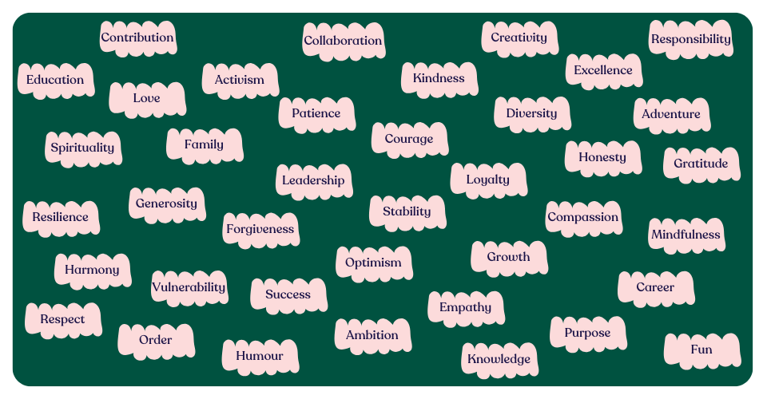
As a group, take a look at the range of values below:
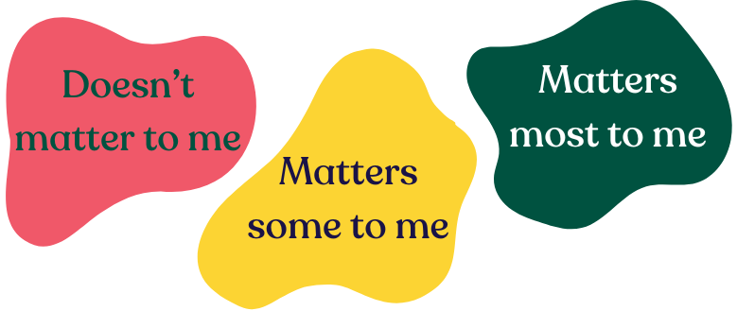
Each choose three values for each of the following categories:

When you’re ready, share these with each other. If you feel comfortable doing so, discuss the reasons for your choices.
Depending on the size of your committee, you should now have at least twelve values that matter the most to you.
Together, narrow these down to six core values. These are the values that should help guide you as a committee. How will they impact the way you lead your group?

…………………………………
…………………………………
…………………………………
…………………………………
…………………………………
…………………………………
The Power of Perceptions
Have you ever stopped to think about how your group is perceived by potential new members?
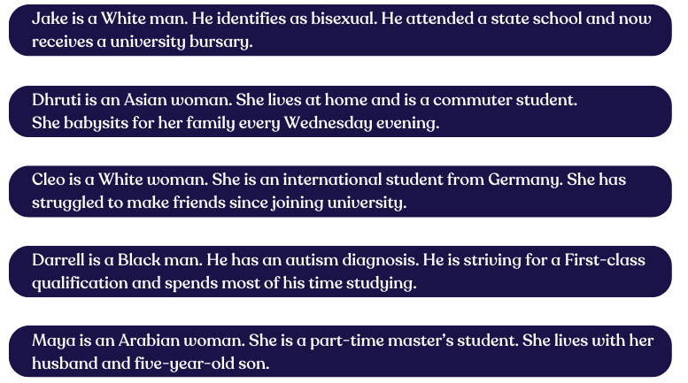
As a group, read through the following descriptions:

How might these example students perceive your group? What could you do to address this?
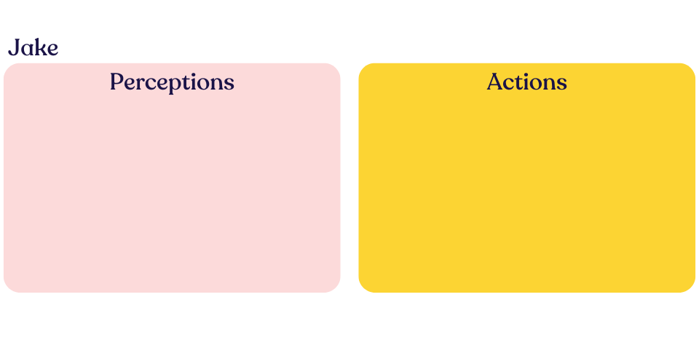
- ……………………….
- ……………………….
- ……………………….
- ……………………….
- ……………………….
- ……………………….
- ……………………….
- ……………………….
- ……………………….
- ……………………….
- ……………………….
- ……………………….
- ……………………….
- ……………………….

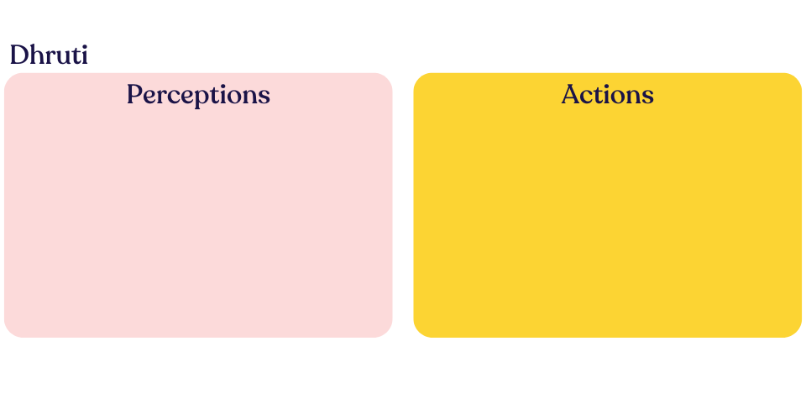
- ……………………….
- ……………………….
- ……………………….
- ……………………….
- ……………………….
- ……………………….
- ……………………….
- ……………………….
- ……………………….
- ……………………….
- ……………………….
- ……………………….
- ……………………….
- ……………………….

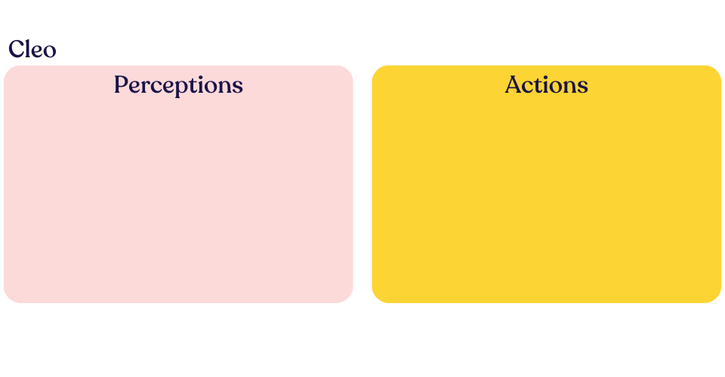
- ……………………….
- ……………………….
- ……………………….
- ……………………….
- ……………………….
- ……………………….
- ……………………….
- ……………………….
- ……………………….
- ……………………….
- ……………………….
- ……………………….
- ……………………….
- ……………………….

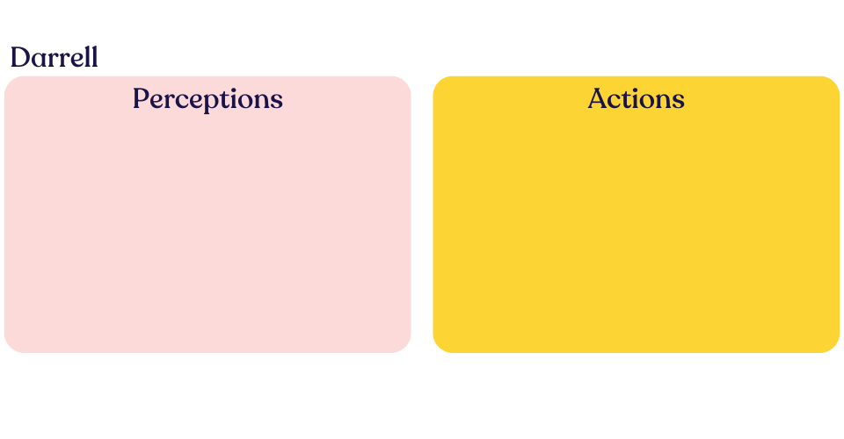
- ……………………….
- ……………………….
- ……………………….
- ……………………….
- ……………………….
- ……………………….
- ……………………….
- ……………………….
- ……………………….
- ……………………….
- ……………………….
- ……………………….
- ……………………….
- ……………………….

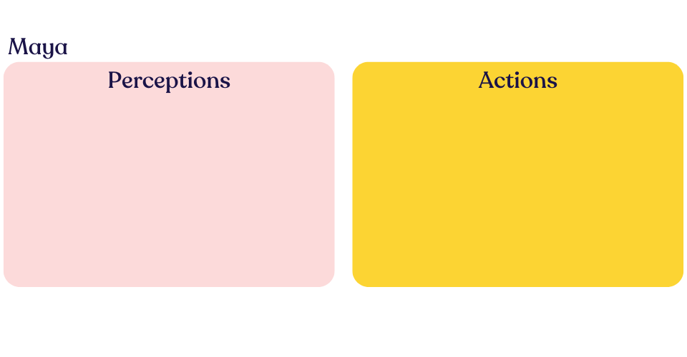
- ……………………….
- ……………………….
- ……………………….
- ……………………….
- ……………………….
- ……………………….
- ……………………….
- ……………………….
- ……………………….
- ……………………….
- ……………………….
- ……………………….
- ……………………….
- ……………………….

Wheel of Power and Privilege
The Wheel of Power and Privilege shows the different degrees to which a person can be marginalised or have power over others in society based on their characteristics.
Where are you a part of an advantaged group and where are you a part of a disadvantaged group?
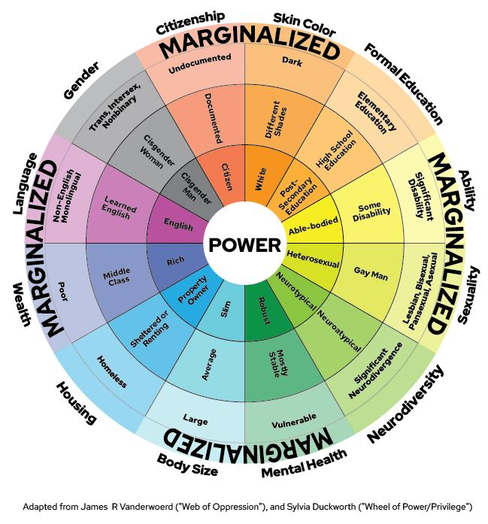
Where might your members be? How might this affect how they interact with your group?
Our Equality Statement
………………………………………………………………………………………………………………………………………………………………………………………………………………………………………………………………………………………………………………………………………………………………………………………………………………………………………………………………………………………………………………………………………………………………………………………………………………………………………………………………………………………………………………………………………………………………………………………………………………………………………………………………………………………………………………………………………………………………………………………………………………………………………………………………………………………………………………………………………………………………………………………………………………………………………………

Our EDI Action Plan
Barrier to Participation | Action(s) | Who Is Responsible? | When Will It Be Done By? | Outcome(s)

Our Review
Strengths:

Areas for Improvement:

Potential Future Actions for Next Year:

