

Introduction

This guide sets out how to navigate the pages of the Academic Representation Engagement Hub for Academic Representatives. All Course/PGR, School and Faculty Reps have access to the Hub as a bespoke platform to use throughout their role. The following sections introduce the Hub as a whole and subsequently address individual pages and their uses.

Contents:

Contents 1
What is the Academic Rep Engagement Hub? 1
How do I log in? 1
What does the Rep Hub do for me? 1
✍️Action & Notes Log 1
Feedback Questionnaire 1
📖Training Links 1
A walkthrough of the Rep Hub… 1
Additional Information 1

What is the Academic Rep Engagement Hub?

“The Rep Hub” for short is your one stop shop to access all the training and resources for your role! Here are some of the key things you can use the Hub for:

✅Find other Reps in your school or Faculty
✅Access and log Training modules
✅Log what you’re working on, to let us know and track your achievements throughout your role
✅See what other reps are working on and collab with them
✅Nominate for Rep of the Month
✅Access key resources

Take a more detailed look in our ‘what does the Hub do for me’ section below!

How do I log in?

To login, you will be sent a unique link and code by the SU team after you enter the role. If you don’t think you have received this, or would like it resent to you, contact us at bristolsu-representation@bristol.ac.uk !

Each user has a unique link and password, and email verification and password reminders are also included to ensure that your access to the Hub and the information inputted is as secure and safe as possible. Once you have entered your role you will be sent our Core Training module, which includes information about the Hub as well as other key information for your role.

What does the Rep Hub do for me?

📃Reps in your Faculty

The Hub Provides a streamlined list of all the reps in a specific faculty. You will only be able to see reps in your faculty, and can search or filter the list by school, year of study, school, level of study, and Rep categories for either Course Reps or Faculty Reps.
💡Use this page to check out what other reps are working on and contact them if you would like to collaborate or share ideas

📝What I’m working on

This section is your space to log what you’re up to in your role – it can be easy to forget by the end of the academic year everything you have achieved! This is also visible to other reps, so by sharing what you are working on you can inspire others or encourage them to share ideas.

💡If you’re working towards the Bristol PLUS award, this is a great space to map your activities as a rep, and our team can verify that your rep role counts towards your voluntary hours on the PLUS award

✍️Action & Notes Log

As a Rep, you can let us know what projects you are working on by filling in the actions and notes log. On this page you provide us with detail about the project, time duration, any collaborators, and much more. Unlike the ‘what I’m working on’ section, this isn’t visible to other reps.

This is your space to use for note taking in SSLCs, goal setting or whatever else you would like to use it for. This info is useful for us to have so that we know what you are up to and how best to support you. Additionally, we would have more info to add to any recommendation and support letters you might need at the end of your role.

Feedback Questionnaire

Our team are here to support you in your roles and make sure you have all the tools to excel in your role and have a great time as a Rep! Use this feedback form to send us any suggestions or feedback on your experience or our resources/training.

You can also contact us anytime at Bristolsu-representation@bristol.ac.uk or at our monthly Rep Drop ins (we share the dates of these in our monthly newsletter or on the SU Events page).

📖Training Links

The Hub has a page with quick links to trainings and corresponding forms for logging training completion. Here you can find your Core Training module, as well as optional training opportunities like our Meeting Hosting Training or Communication Training modules.

If you become a School Rep as well as being a Course Rep at the start of the academic year, you can access the School Rep training module here too!

💡Feel free to use this throughout your role, and don’t forget to log your Core Training, especially if you are working towards a LinkedIn recommendation

🏆Rewards and Recognition

You can find the Rep of the Month form on this page, where we really encourage you to nominate fellow reps for their outstanding work! We announce the winner each month in our newsletter (you can find an archive of previous newsletters on the ‘useful resources’ page).

You can also find the LinkedIn recommendation criteria here if you’d like to work towards this during your role.

📚Useful Resources

Here you can find Faculty Student Staff Liaison Committee meeting minutes, resources shared at previous Rep Con events, useful SU research, the handbook for your role and more! If there is anything that would be helpful for us to share on this page, do let us know.

💡Use these resources to support your ideas and build a data informed approach

🤝Additional Support

Access support resources on this page, with links to the SU wellbeing page, university wellbeing support and more.

A walkthrough of the Rep Hub…
This section sets out a step-by-step walkthrough of the pages in the Hub with descriptions.

1. Type in your Uni ID and password

In the landing page, type in your Uni ID (seven-digit ID in the format “ab12345”) into the Uni ID space and your unique 5-digit pin, which you would have received in an email.
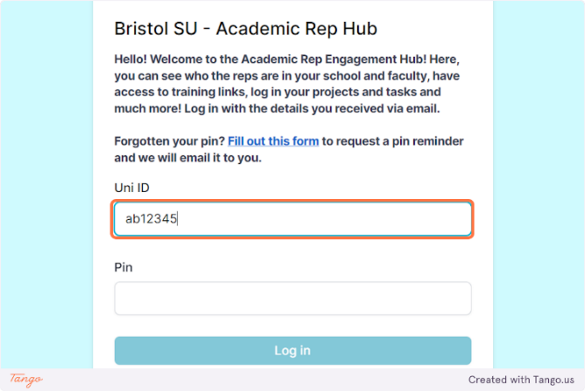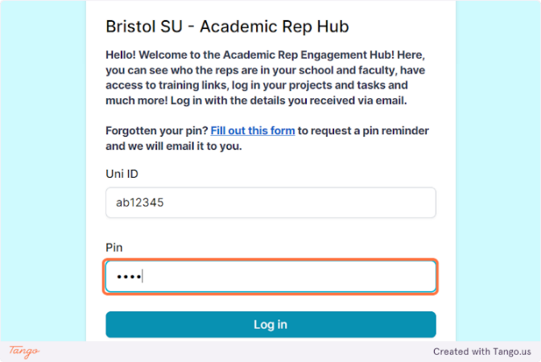

2. Click on Log in
Click on the “Log in” button.
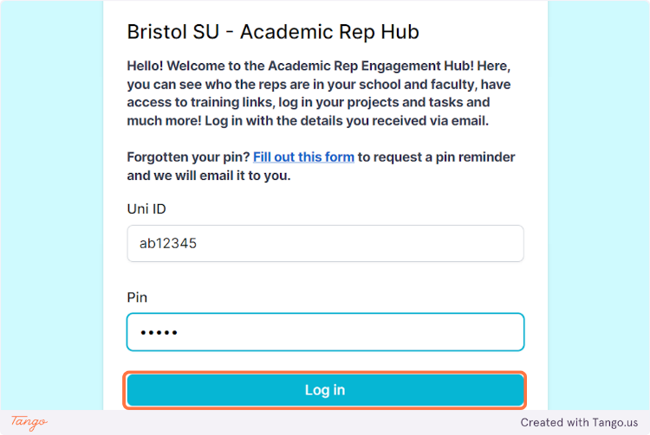

3. After logging in, the first page is your homepage.

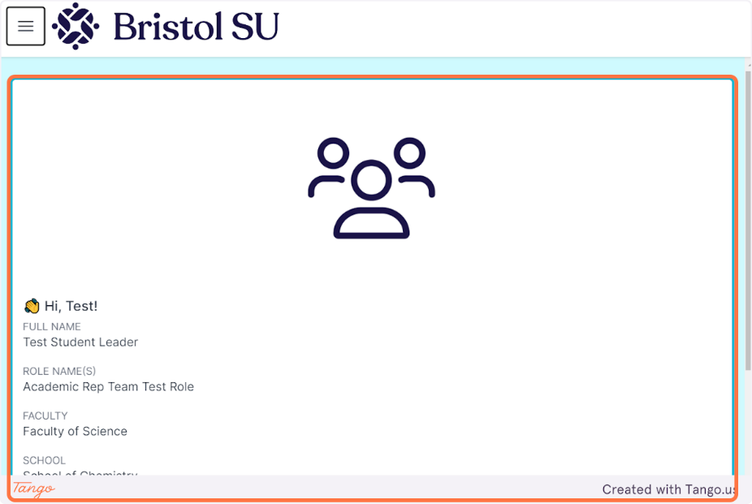
The navigation pane is on the left- hand side of the homepage and includes the following pages:
- Homepage
- What I’m working on
- Reps in your faculty
- Training
- Actions/notes log
- Feedback questionnaire
- Support in your role
- Useful resources
- Possibly other pages, for example a handover form will appear here towards the end of the academic year, and we will also add a button to re nominate yourself during the TB2 Elections

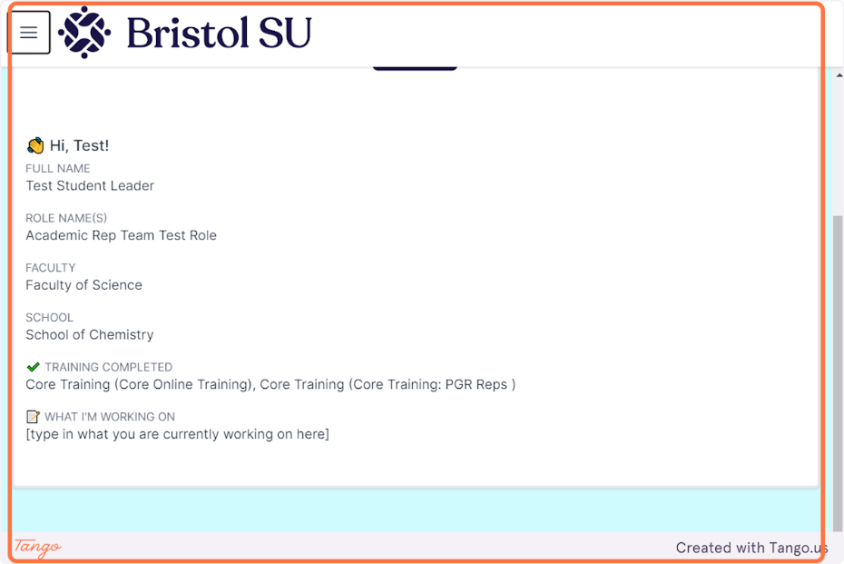

Drag the slider from top to bottom to reveal more details.
On the homepage here, you can upload a profile picture to make the Hub feel more personal. The homepage shows your full name, current role, school, and faculty. You can also view which training has been registered as completed and which ones are still pending.
There is also the ‘What I’m Working On’ section which can be updated through the Hub and shows on your profile, to both staff and reps.

4. Click on the "✍️ what I'm working on" page…
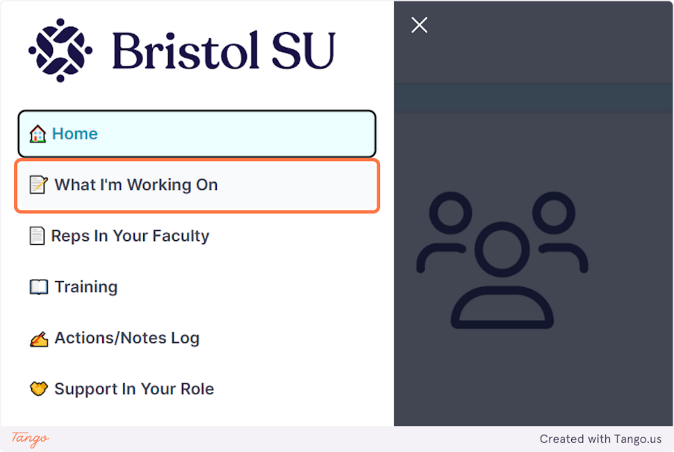

5. Click on ✍️ What I'm Working On Form…

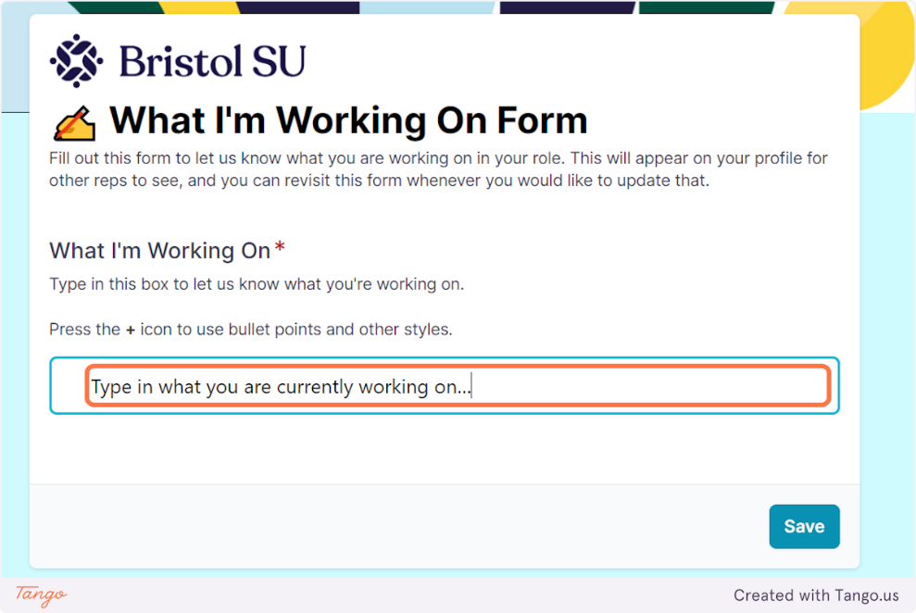
You can fill in this form to display what you are currently working on, on the homepage.

Simply type your text into this box and click save, then the text appears on your homepage.
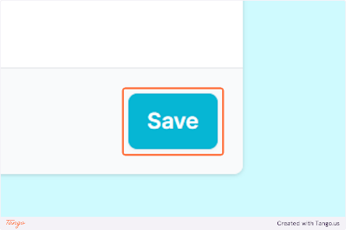
Click on Save.

6. The Form will be submitted and the text you have written will be displayed on your home page.
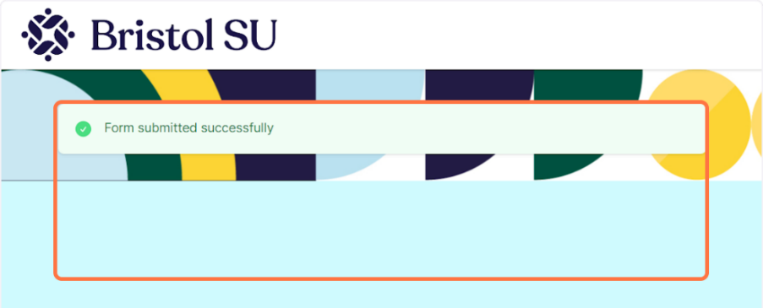
7. Click on the "Reps in Your Faculty" page…
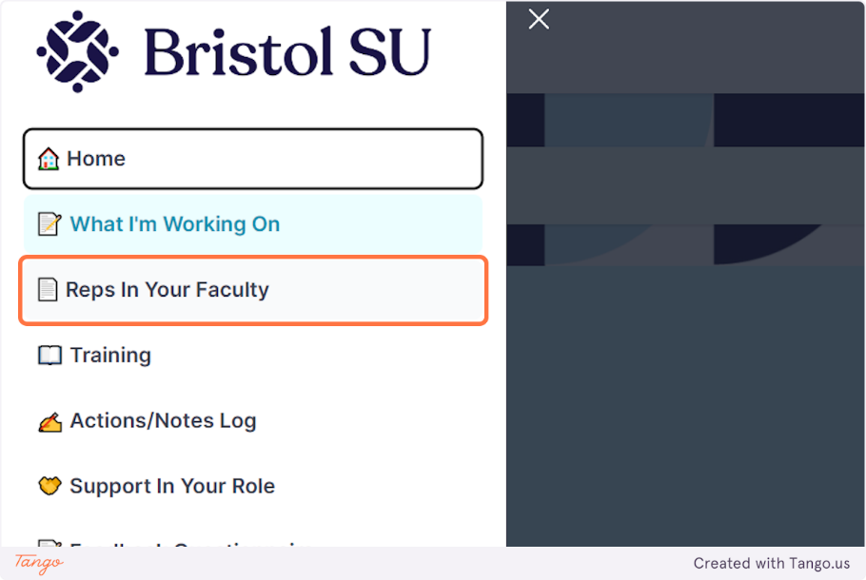

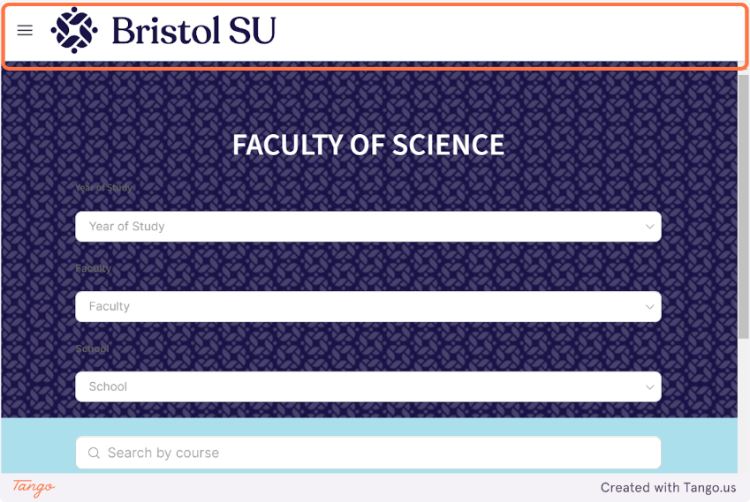
8. On this page you'll see the list of all the reps in your school and faculty.
On this page, you can also search the list by school, year of study, school, faculty, course, and filter by Rep categories for either course reps or faculty reps.

The detail of each Rep is presented in tile format which displays their Uni Email, current role, rep category and year of study at a glance.
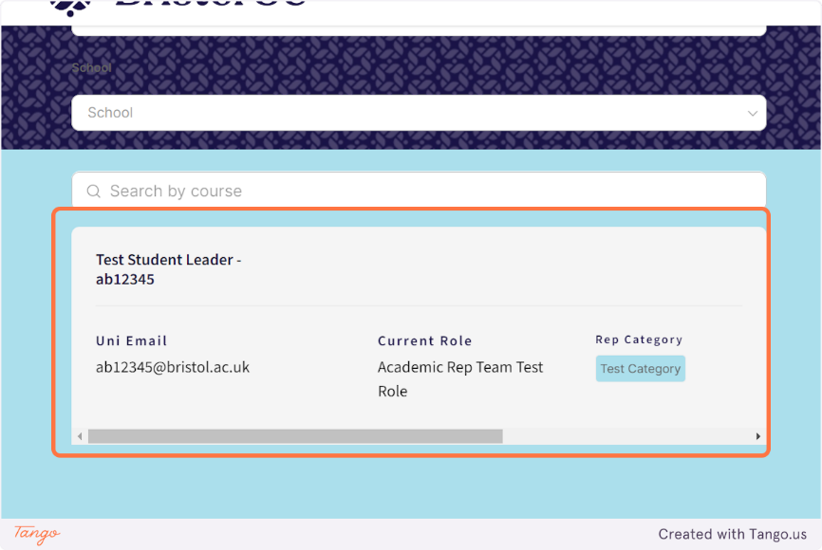

9. Drag the slider across from left to right to reveal the "click to view more" button.
More information is provided in a pop-up window through the “Click to view more” button. This is where you can see what other reps are working on (if they have updated this !)

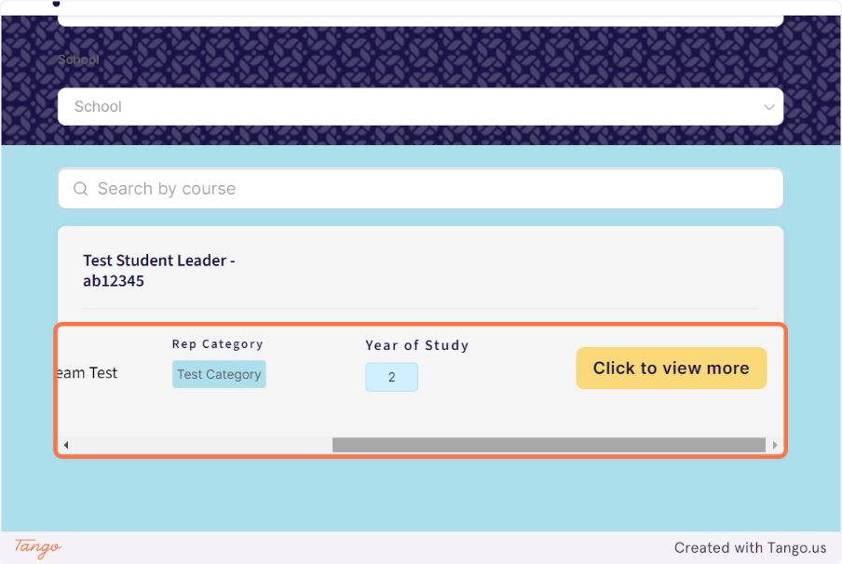

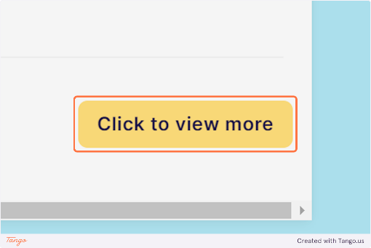

10. A pop-up window shows more details about the student rep.
Drag the slider from top to bottom to reveal the reps “What I’m working on” notes (displayed on their homepage)
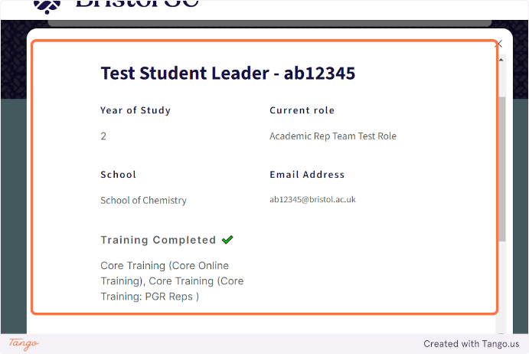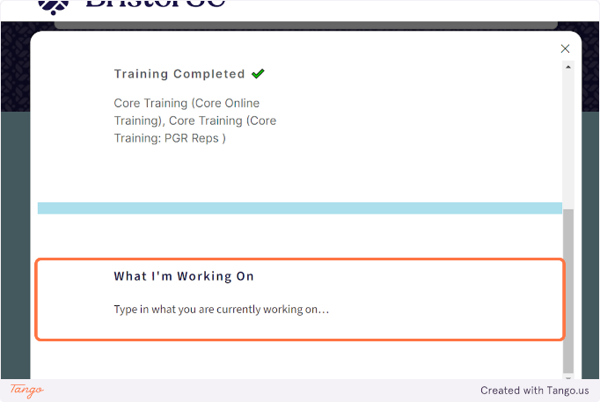

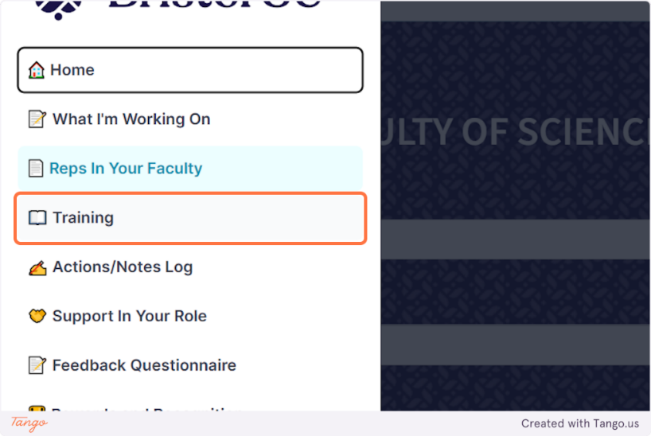

13. Training Page

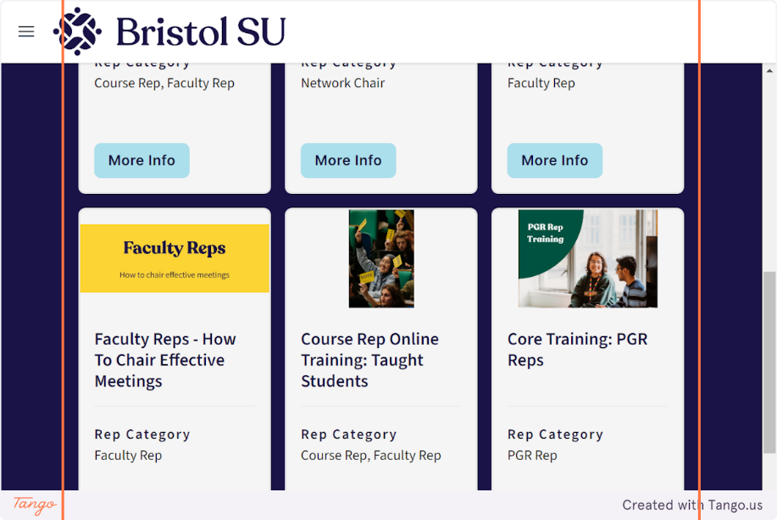
The “More info” button opens a pop-up window with more details on each training. You can filter the training you want to find by ‘core training’ or ‘additional training’

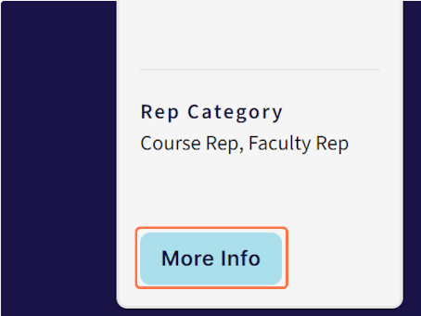
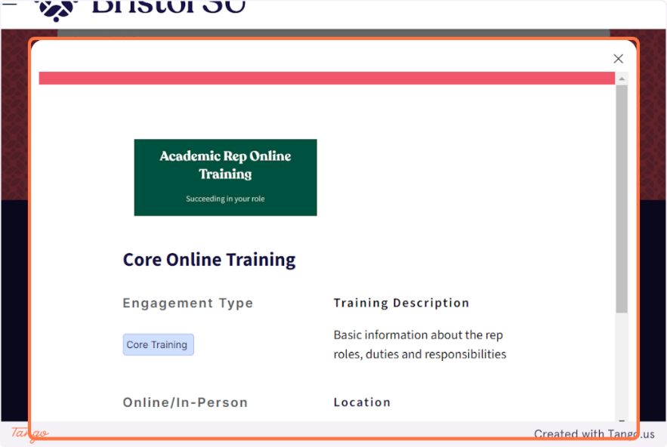

Drag the slider from top to bottom to reveal more information below.
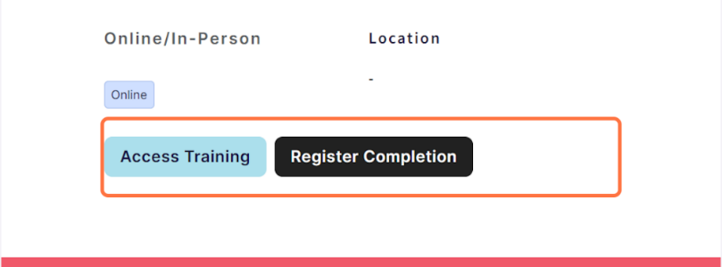
You can either click the “access training” button which redirects to the main page of the training, or the “register completion” button which redirects to the form for you to log the training completed.

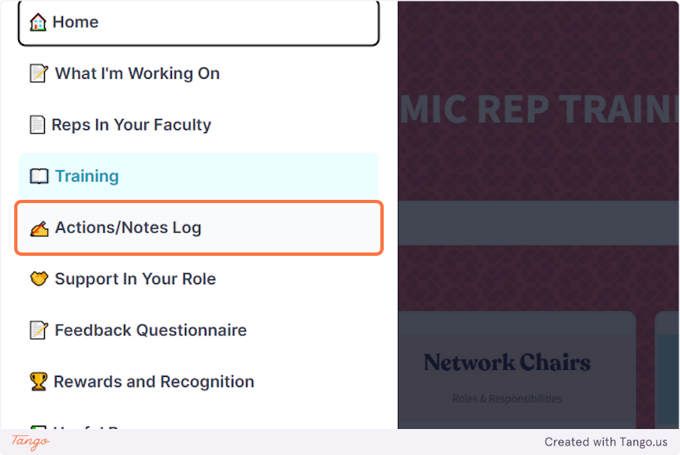

14. Click on the "Actions/Notes Log" page…
On this page, you can fill in a new form in the Action/notes log to let us know what you have been working on, if you are collaborating with other reps and if you want the form to be shared with the collaborator.

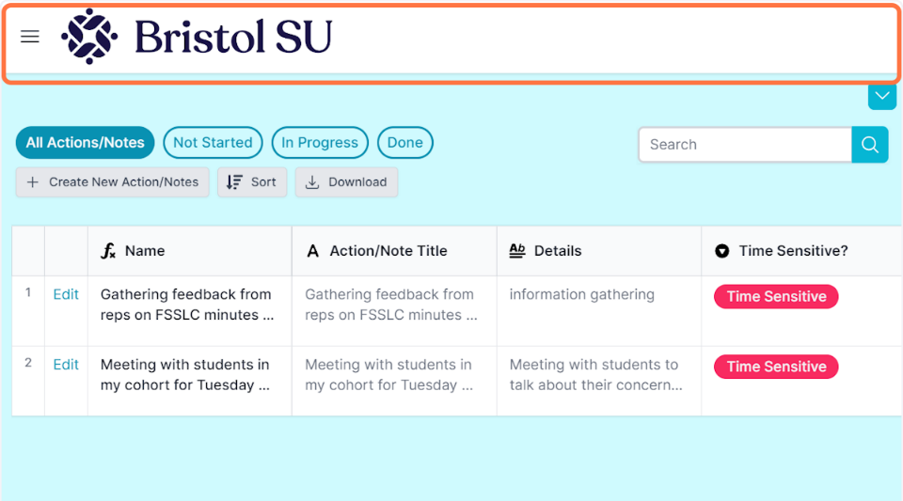

15. Click on "Create New Action/Notes"

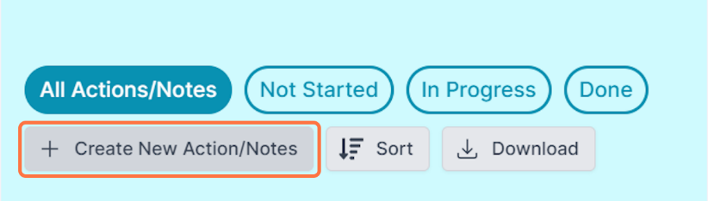
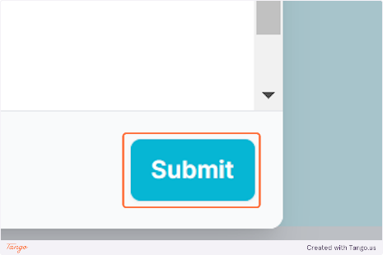
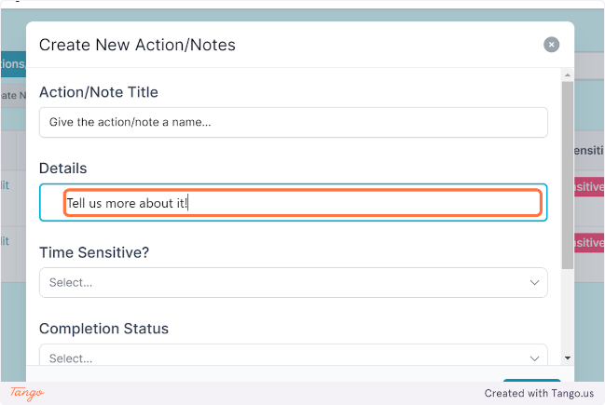
Type in the title of your action and provide more details.
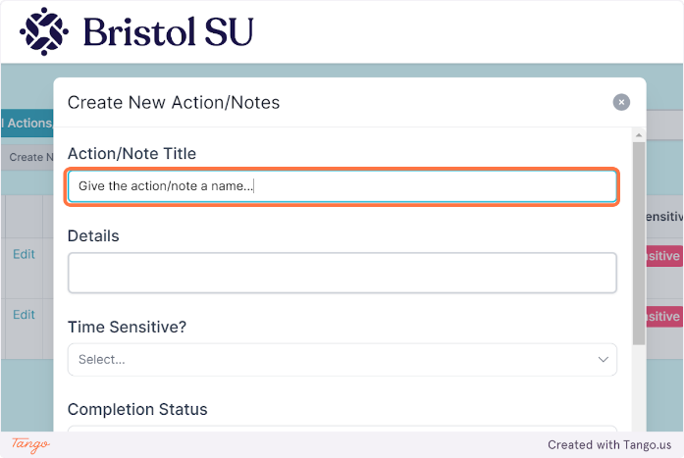

After providing the requested information on the form, Click on Submit. The new note will then appear in the actions/notes list.

17. Using the "Feedback Questionnaire" page…

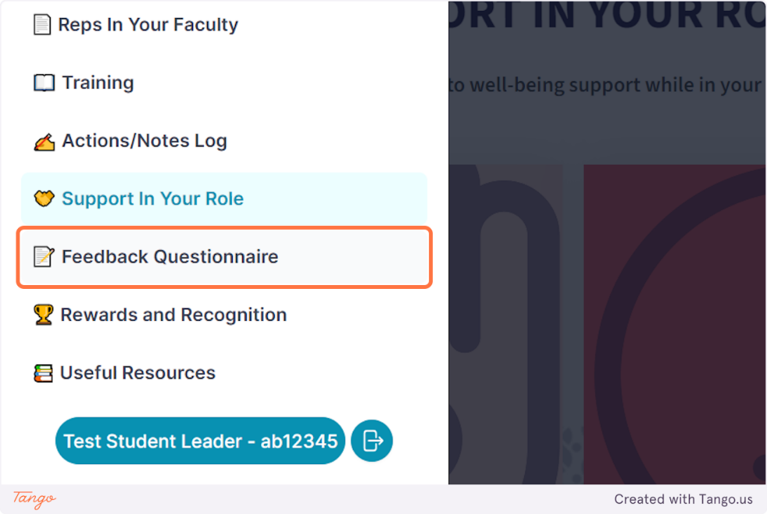

Available throughout the year, you can fill in the feedback questionnaire to reflect on your journey as reps and on your work with staff at the SU or University.

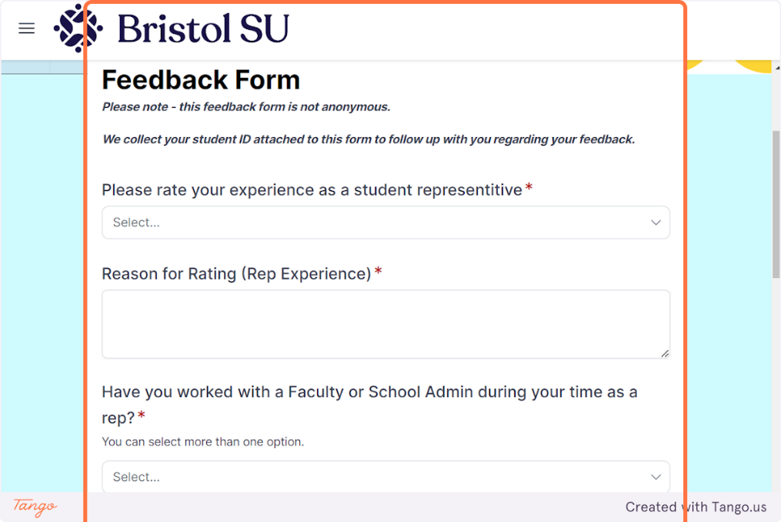

Additional Information

Please feel free to contact the team at bristolsu-representation@bristol.ac.uk to give us feedback on your experience using the Hub and share ideas on how we can improve your experience!
We can also answer any questions you have. This guide will also be available to you on our website, under the ‘Support for Reps’ section. If you have any feedback, suggestions or queries about the Hub, please do get in touch!

